With vibe coding implement the playwright/typescript or any other tool which you work say Selenium/Python

Ans:-
- In Ask mode, I added the prompt as Read my entire workspace to understand and analyze how java selenium is implemented in the codebase and tell me what are all the impacted files.I want to implement the playwright and python same like selenium java.

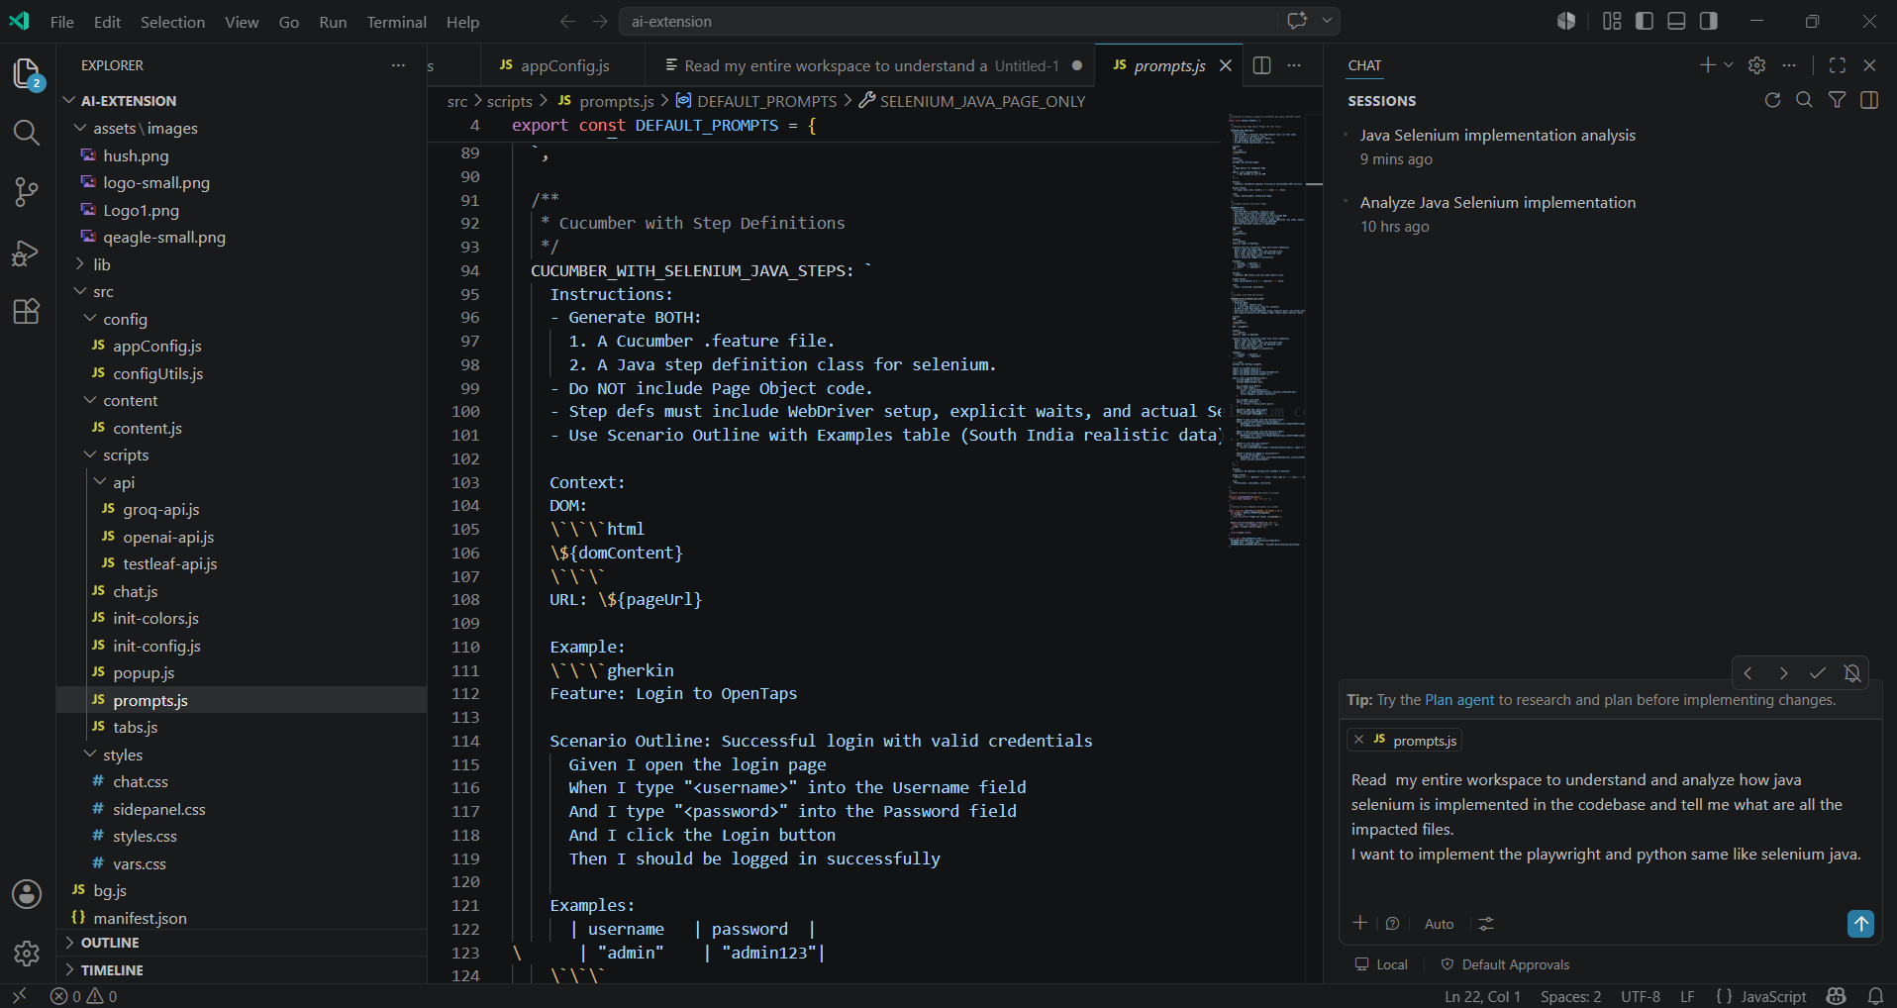
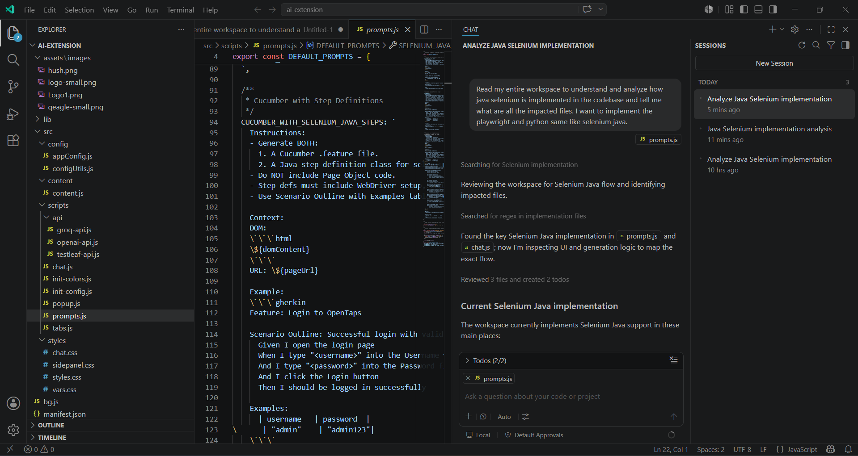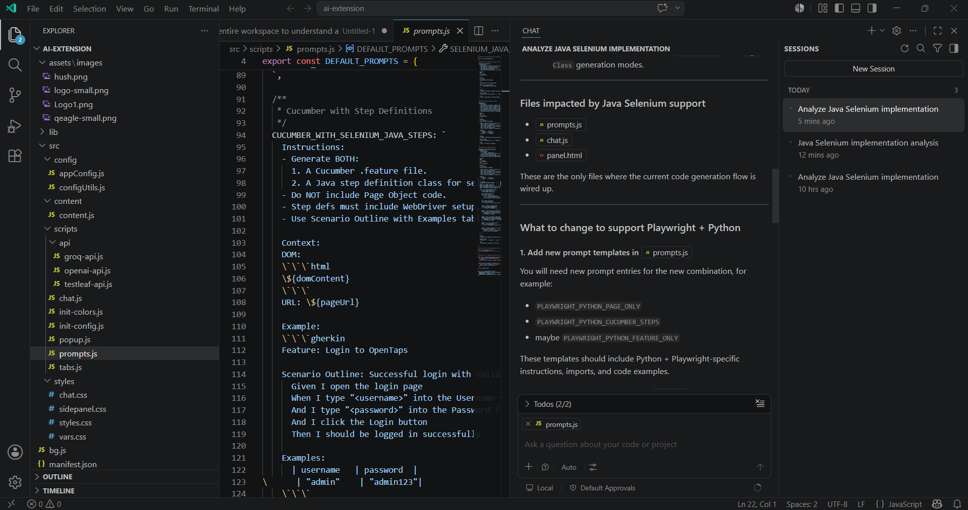

- For implementation, I switched to Agent mode, I gave the prompt as
“Go to prompts.js and add new prompt templates for Playwright python
Take selenium Java as reference”

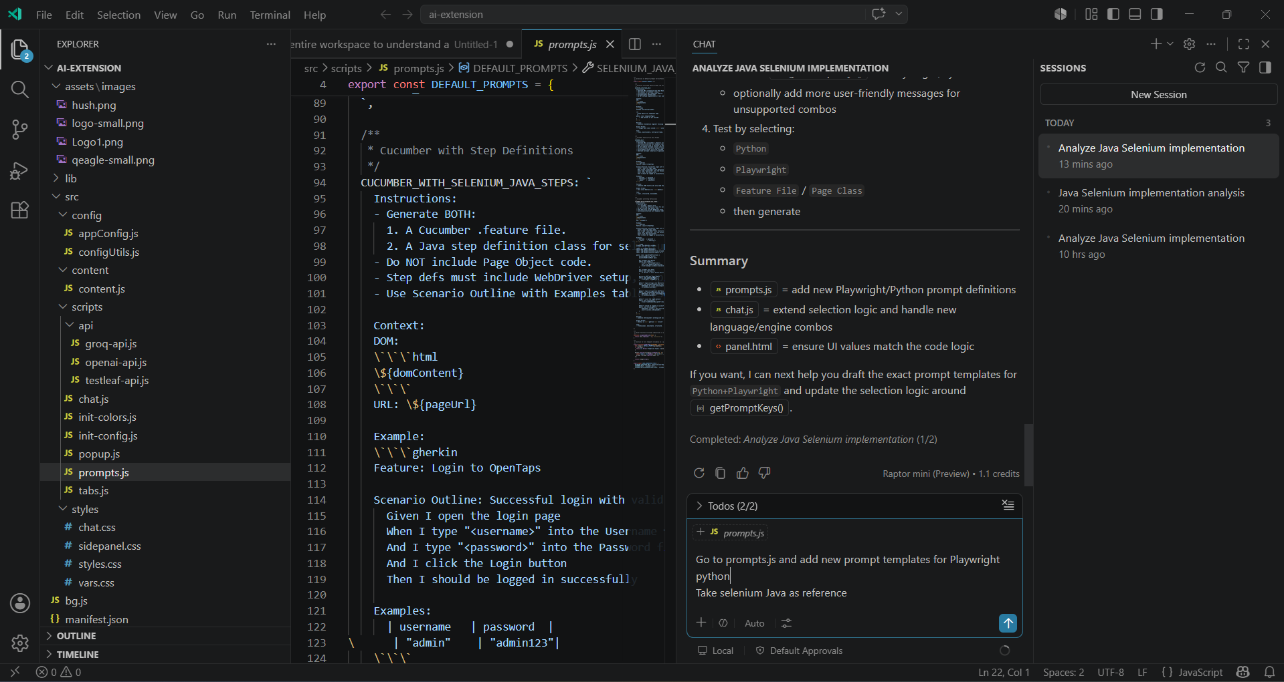

Implemented
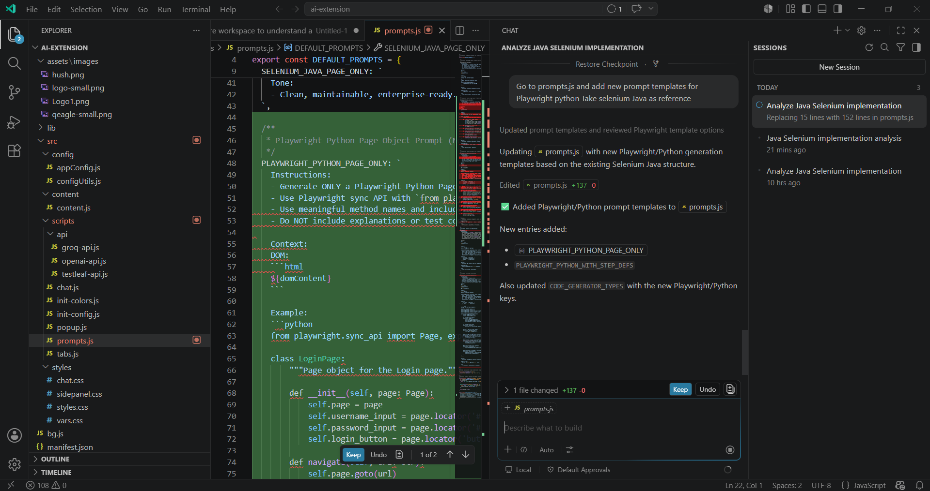

- Extend prompt selection logic and fix language value mismatch in chat.js
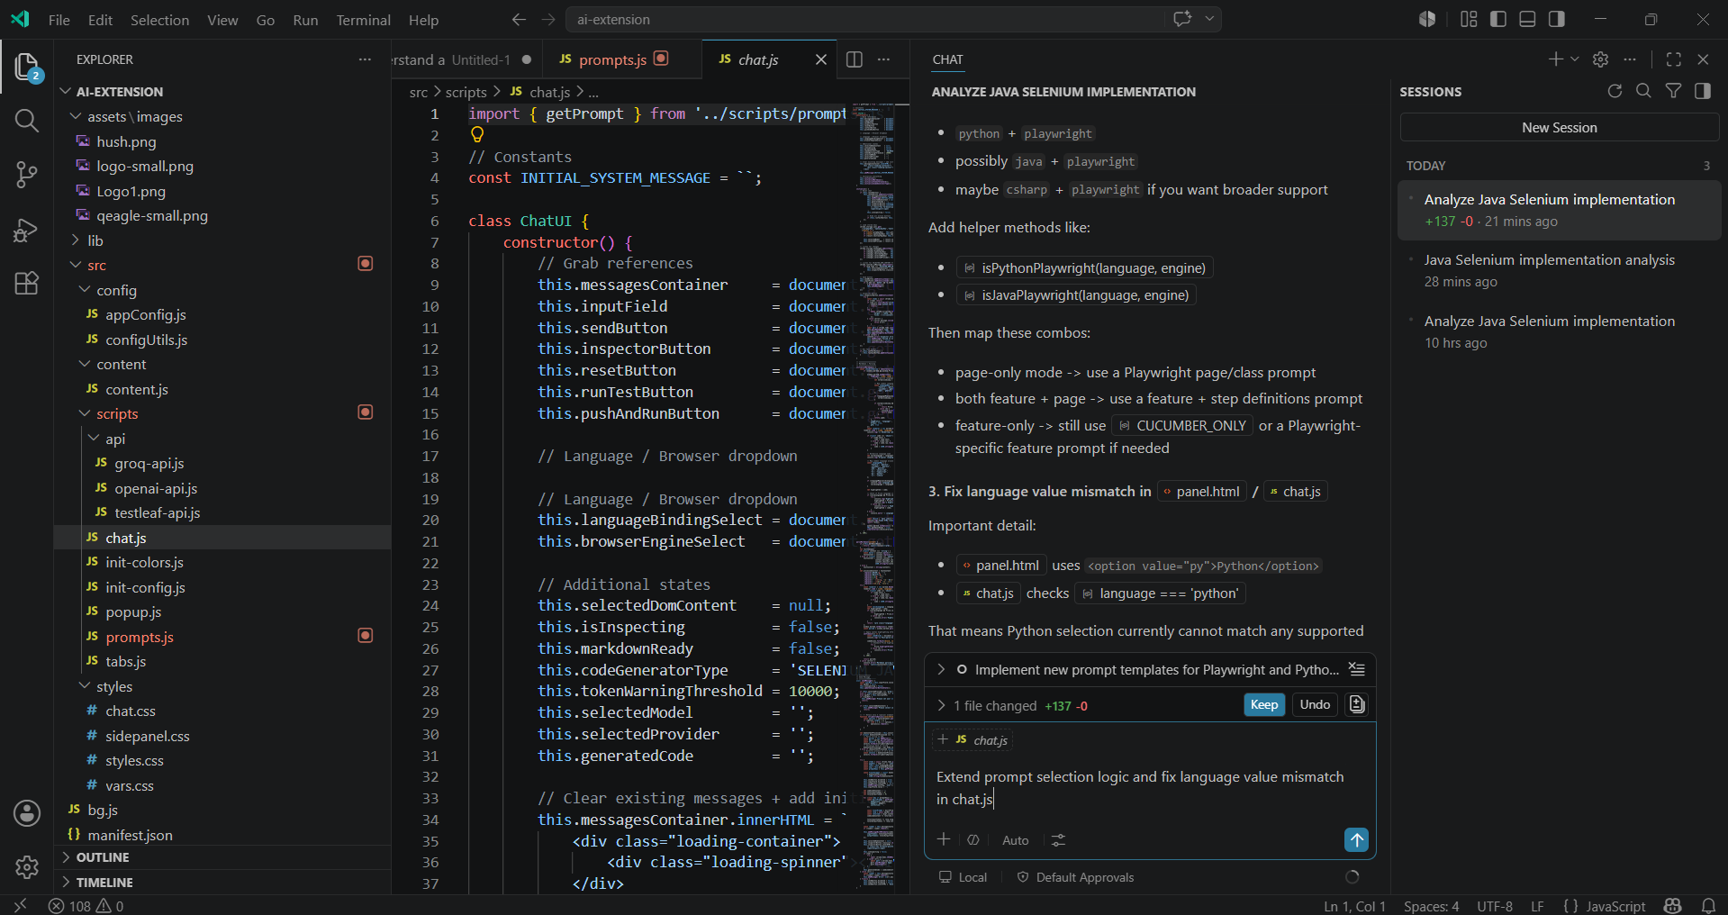
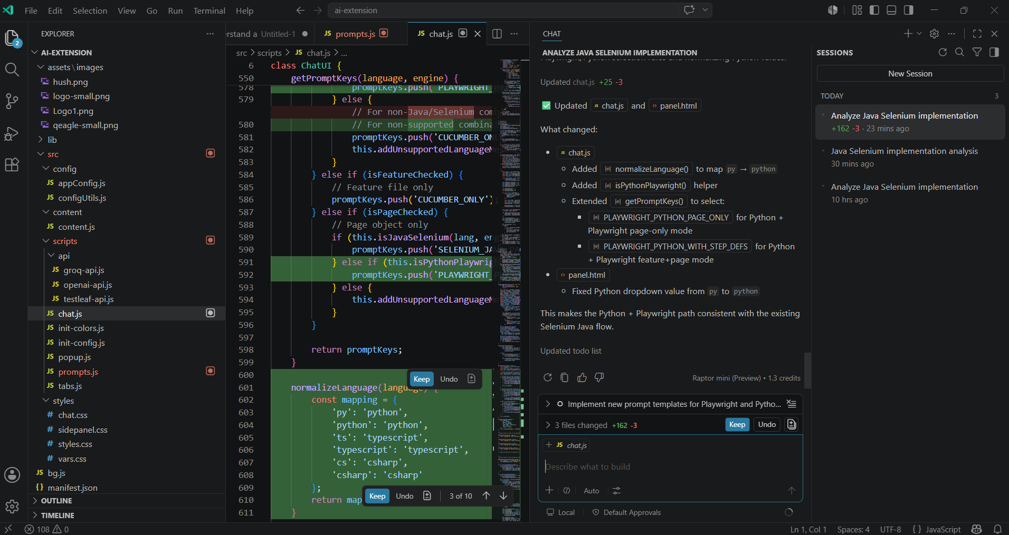

- Go to panel.html Fix language value mismatch
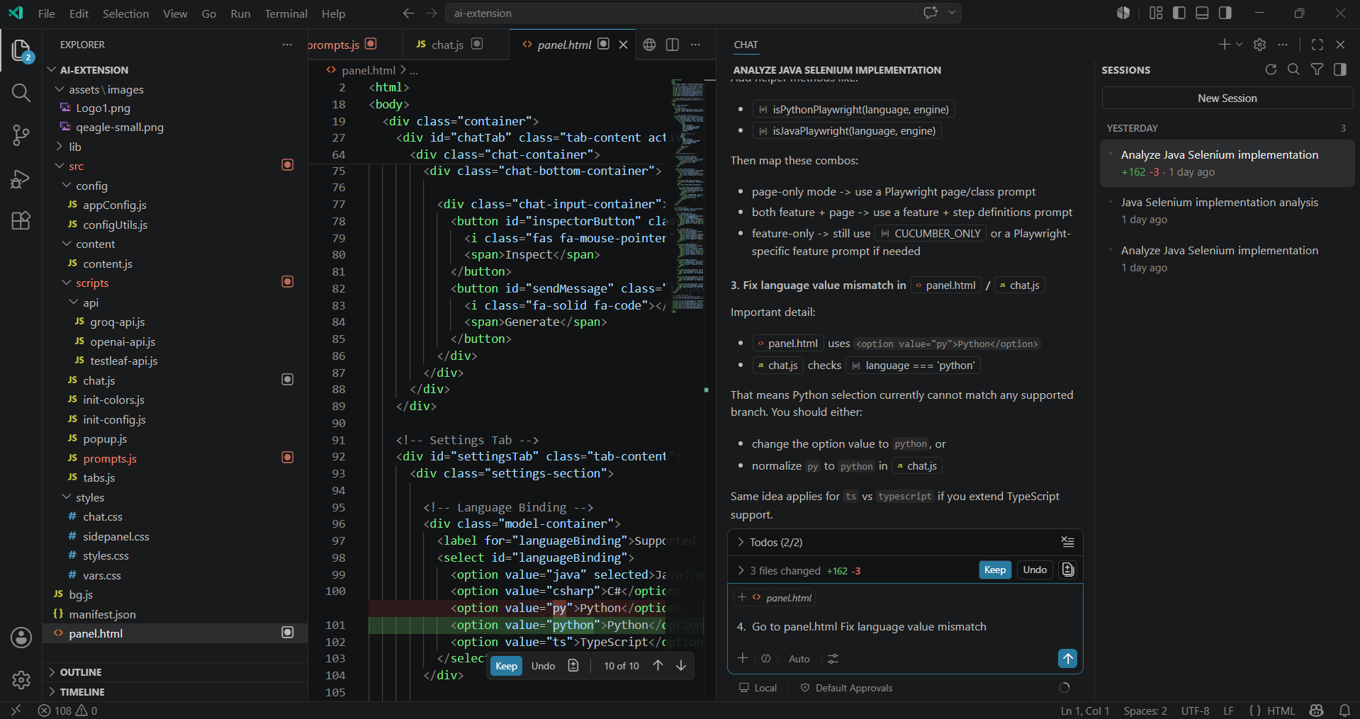
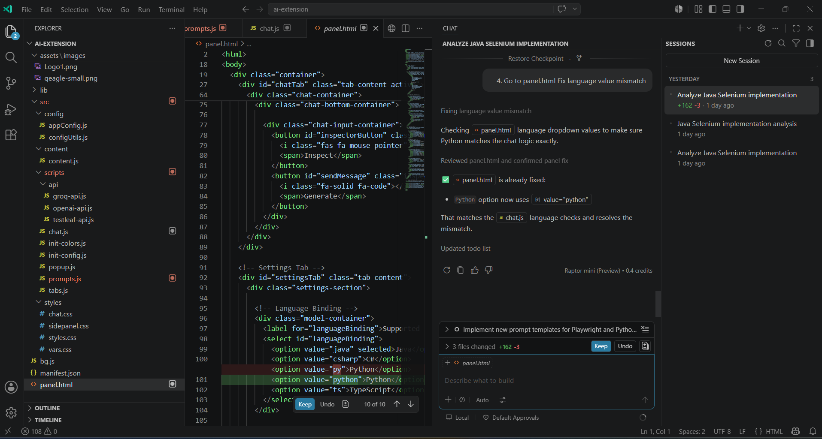

- Verify the Extension is working for Playwright using Python
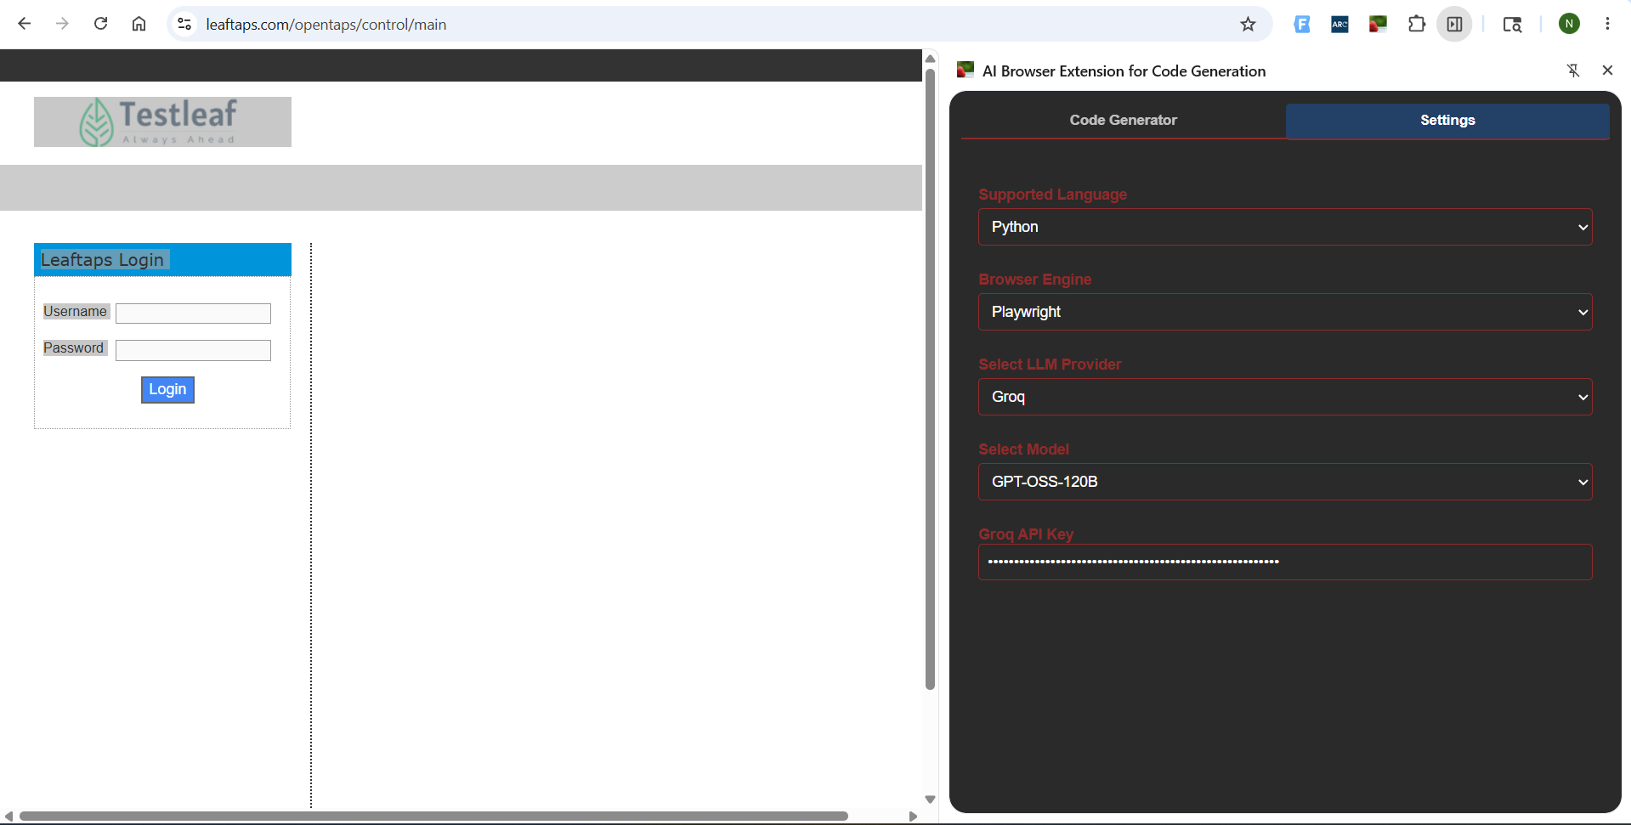

Verified in Code Generator
